**DAILY ONLINE ACTIVITIES SUMMARY**

|  |  |  |  |  |  |  |  |  |
| --- | --- | --- | --- | --- | --- | --- | --- | --- |
| **Date:** | 26/05/2020 | | | | | **Name:** | CHANDANA S | |
| **Sem & Sec** | 4th SEM ‘A’ SEC | | | | | **USN:** | 4AL18CS016 | |
| **Online Test Summary** | | | | | | | | |
| **Subject** | | Design and Analysis of Algorithms(18CS42) | | | | | | |
| **Max. Marks** | | 30 | | **Score** | | | 23 | |
| **Certification Course Summary** | | | | | | | | |
| **Course** | Data Structures and Algorithms in Java | | | | | | | |
| **Certificate Provider** | | | Great Learning | | **Duration** | | | 1.5 Hours |
| **Coding Challenges** | | | | | | | | |
| **Problem Statement:** 1. Write a program in C to print all permutations of a given string using  pointers. | | | | | | | | |
| **Status:** Completed | | | | | | | | |
| **Uploaded the report in Github** | | | | | YES | | | |
| **If yes Repository name** | | | | | https://github.com/chandushivalingareddy/lockdown-coding | | | |
| **Uploaded the report in slack** | | | | | YES | | | |

**Online Test Details:**

The online test was from module 2 which was about the Divide and Conquer, Decrease and Conquer Approach. There were 30 questions and the duration was 45 minutes. The questions were optimal and were easy. The score that I got in the test is 23/30.

**Snapshot:**

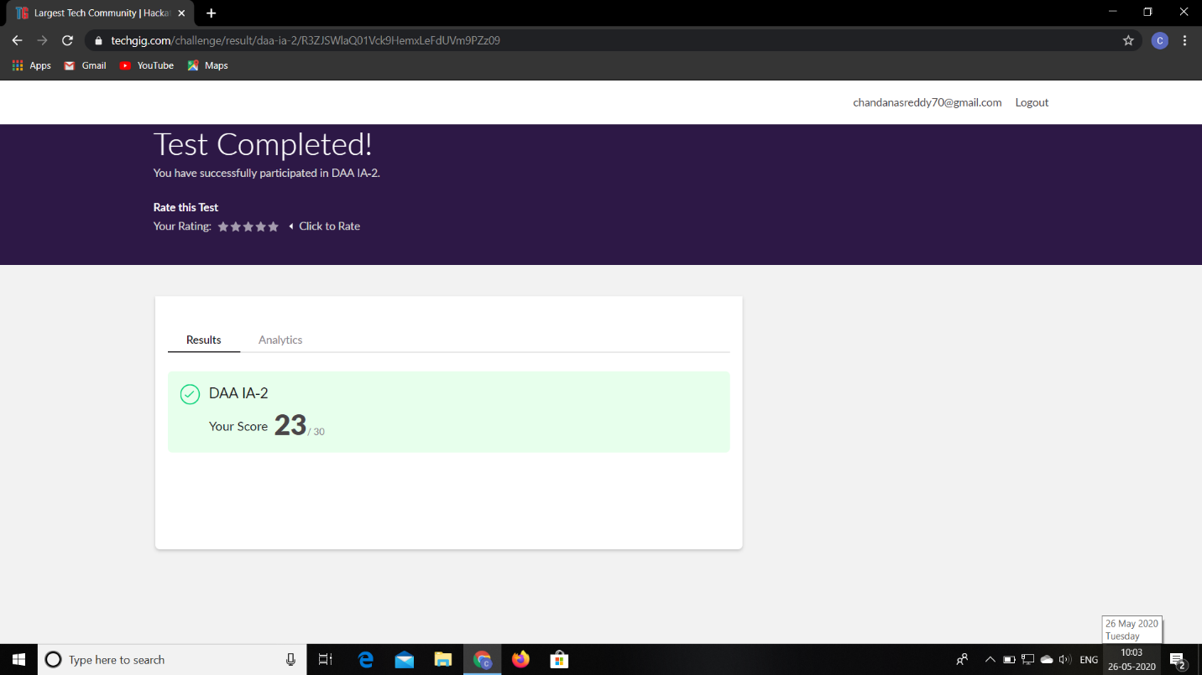

**Certification Course Details:**

**Name of the course**: Data Structures and Algorithms in java

**Certificate Provider**: Great Learning

Today I went through the three sessions of the course that explained about Data Structures and Algorithms in Java. I have gone through the Time complexity, Recursion, Sorting and the problems related to time complexity.

**Snapshot:**

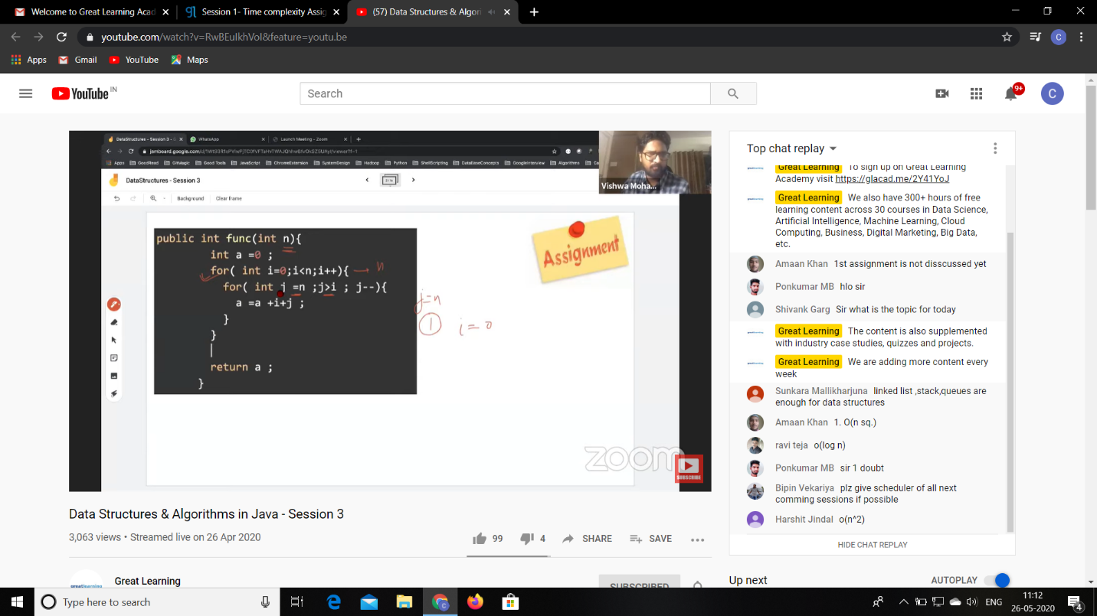

**Online Coding Details:**

Problem 1: (using C language) To print all permutations of a given string using pointers.

**Snapshot:**

